Build An Even Management SystemUsing Salesforce

IiII Introuction:

1.1 Overview :

**Event management is the process of creating and maintaining an event. This process spans from the very beginning of planning all the way to post-event strategizing.**

**At the start, an event manager makes planning decisions, such as the time, location, and theme of their event. During an event, event managers oversee the event live and make sure things run smoothly. After an event, event managers are tasked with reviewing event data, submitting KPI and ROI findings, and staying on the ball for any post-event offerings.**

**All different branches of planning go into event management, including various types of sourcing, designing, regulation checks, and on-site management. In event management, you could be in the process of creating a conference, a product launch, an internal sales kick-off, or even a wedding. Really, any event that requires considerable planning and execution is event management.**

1.2 Purpose :

If your event requires specific registration and has a set guest list, your event management software can easily automate the process.

You can use your Salesforce CRM and event tools to segment your database and design the most strategic guest list for your event.

2.Problem Definition &Design Thinking :

2.1 Empathy map :

­­­­­­­­

Mj



2.2 Ideation& Brainstorming Map :



3.Result :

3.1 Data Model :

|  |  |
| --- | --- |
| Object Name | Fields in the Object |
| Object 1 | |  |  | | --- | --- | | Field label | Data type | | Student | Text | | Attendees | Checkbox | |
| Object 2 | |  |  | | --- | --- | | Field label | Data type | | Speaker | Checkbox | | Vendors | Checkbox | |

3.2 Activity& Screenshot

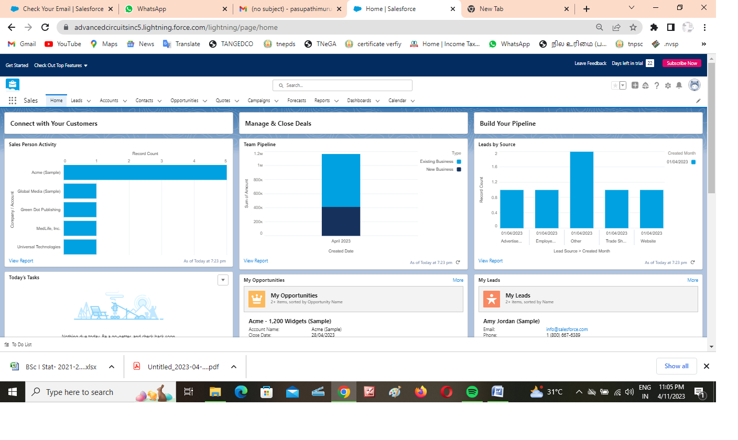Activity : 1 Salesforce Login

Milestone 2 : Object

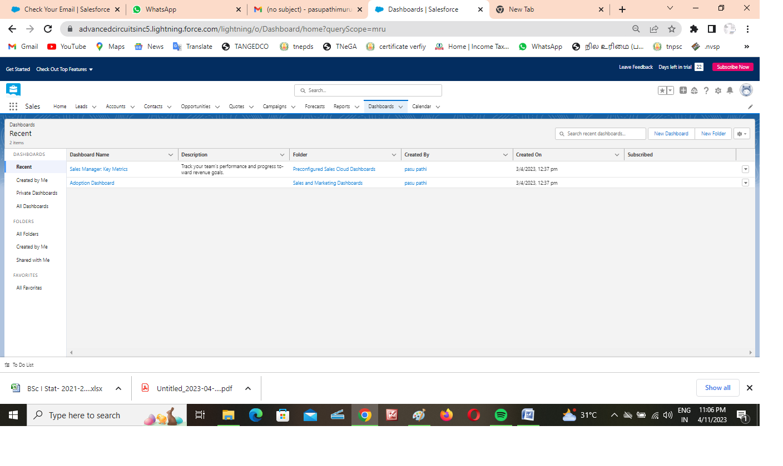

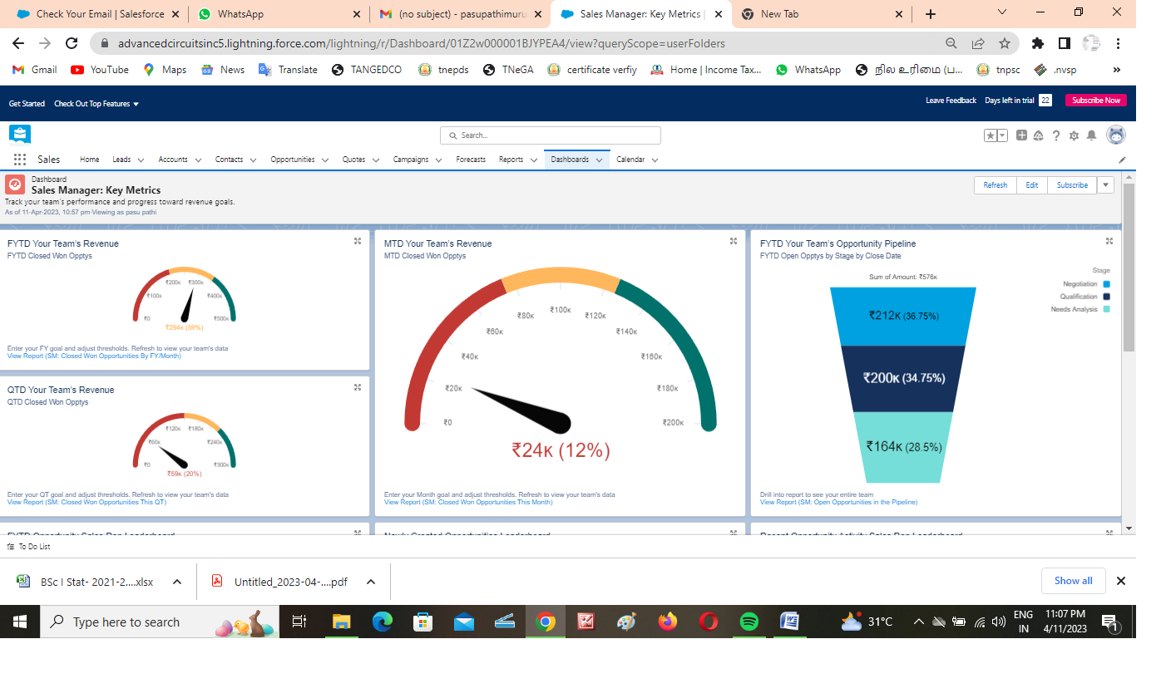Milestione 3 :

Milestione 4

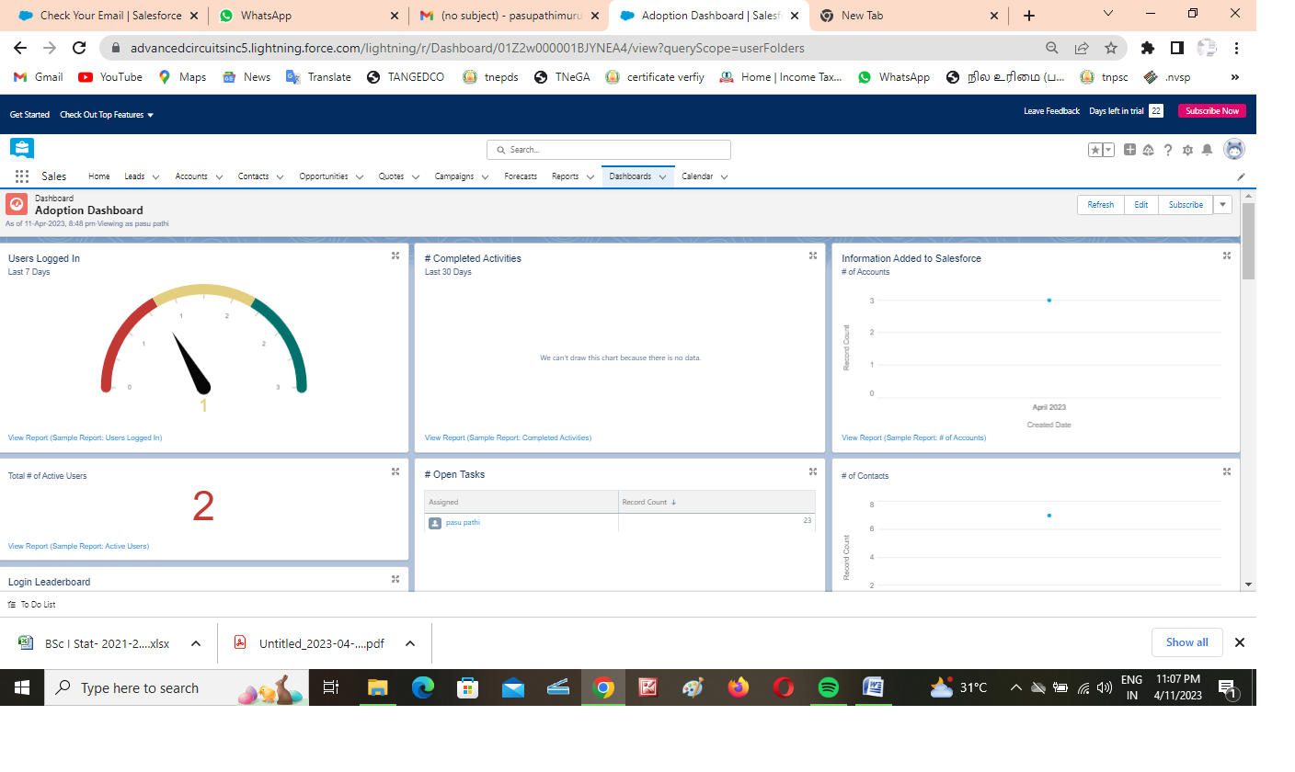

4. Trailhead profile Public URL :

Team Lead - https://trailblazer.me/id/pasum8

Team Member 1- https://trailblazer.me/id/pparthipan2

Team Member 2-https://trailblazer.me/id/mkarky

Team Member 3-https://trailblazer.me/id/mkumar2881

Project Report Template

5. ADVANTAGES & DISADVANTAGE :

For Salesforce users, your database is likely the hub of most of your daily activities. Between tracking data, running reports, and managing communications, it often seems like your Salesforce system can do it all.

6.APPLICATIONS :

Streamline virtual events with landing pages, registration, video production, on-demand content and hosting - all in one place.

Boost attendee turnout with timely reminders and automated calendar blocks.

Automate your event workflows

7.CONCLUSION :

A standalone salesforce for a project management system is certainly an option. However, a project management tool not affiliated with Salesforce won't be able to connect to Salesforce objects. Therefore, you will need to interface the project management system with Salesforce if you want to obtain data automatically (to, for example, change a project status in the project management system).

8.FUTURE SCOPE :

A virtual event is an event that takes place online instead of in a physical location. Virtual events allow for remote attendance from anywhere in the world and often replace equivalent in-person events, such as meetings, presentations, lectures, or seminars. Common formats include online meetings, webinars, and webcasts, with live audio and video sharing in real-time.